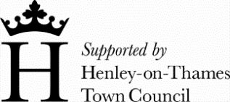
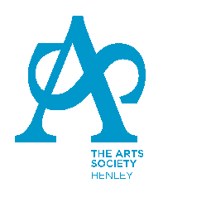
THE ARTS SOCIETY HENLEY
(Registered Charity 289323)

Membership Application Form

Please complete this form and email it to membership.henley@theartssociety.org

Subscription is £50 for the calendar year (£25 if joining after end of July) payable by bank transfer:
Unity Trust Bank Sort Code 60-83-01 Account Number 20368890
Please use your postcode as the reference

Or by cheque; payable to ‘The Arts Society Henley’ and posted to the membership secretary with this form.

Title | Forenames | Surname

Address
Postcode

email | landline | mobile

Preferred Attendance Session
Morning | Afternoon

Members will receive membership cards, the TASH annual lecture programme and The Arts Society magazine by post. Other communications are normally by email.

GDPR COMPLIANCE
- Members’ details will be processed fairly and lawfully and in accordance with the agreement entered into with you on your admittance to membership. This will ensure that you receive the latest news and information about all upcoming events.
- Members’ details will be passed to The Arts Society for inclusion in the mailing of the magazine and other communications, including information about any upcoming national events or items of legitimate interest
- Members’ details may be passed to The Arts Society Area, or to other affiliated societies, for the purpose of disseminating relevant information of legitimate interest.
- Members’ details will be kept safely and securely and members have the right to opt out of our communications at any time.

Signature ________________________________ Date_________________

As a registered charity The Arts Society Henley can claim a refund of the amount of tax paid on your subscription. Please consider completing a Gift Aid Declaration form.

The Arts Society Henley
Registered Charity 289323

Gift Aid Declaration

Title ………. Forename(s)…………………………………………………..

Surname …………………………………………..….………

Address ………………………………………………………………….………

……………………………………………………………………………………

…………………………………………………….. Post Code …………………

I wish the Arts Society Henley to treat all donations made by me in the last 4 years, and all donations I make hereafter, as Gift Aid Donations until I notify the Arts Society Henley otherwise.

I am a UK taxpayer and understand that if I pay less Income Tax and/or Capital Gains Tax than the amount of Gift Aid claimed on all my donations in that tax year it is my responsibility to pay any difference.

Signature ………………………………………… Date ………………………

Please complete this form and email it to membership.henley@theartssociety.org

Please notify the Treasurer if you:
Wish to cancel this declaration, or change your name or home address, or if you no longer pay sufficient tax on your income and/or capital gains.
If you pay Income Tax at the higher or additional rate and wish to receive the additional tax relief due to you, you must include all your Gift Aid donations on your Self Assessment tax return or ask HM Revenue and Customs to adjust your tax code.

