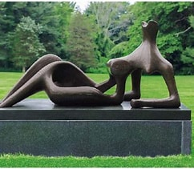
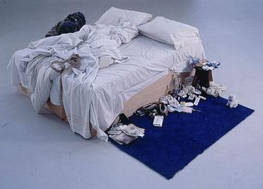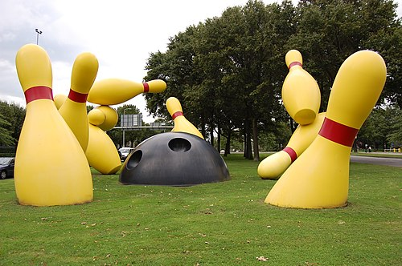

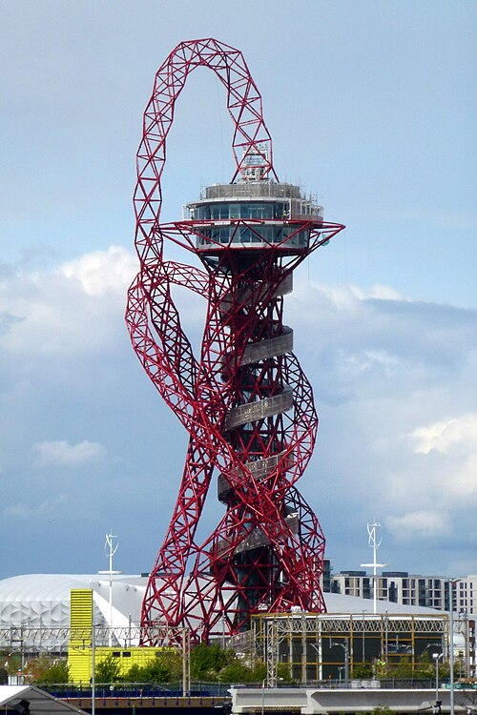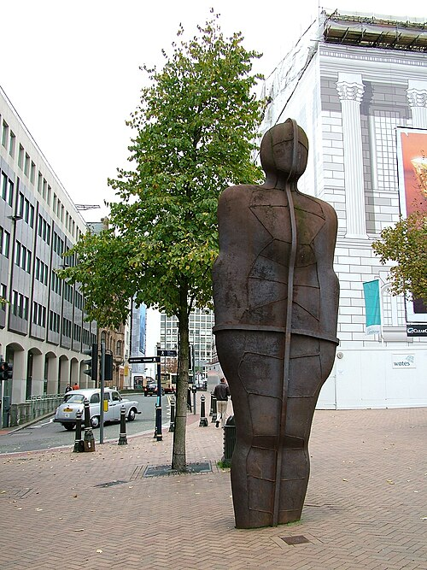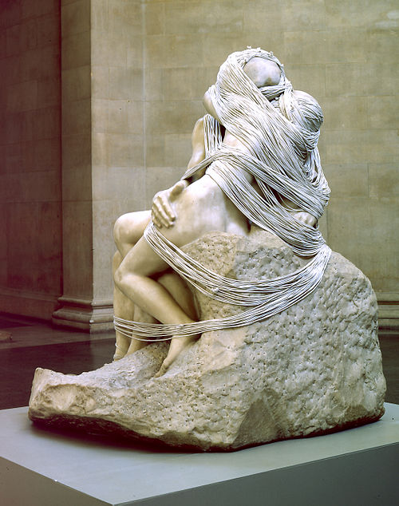
Anish Mikhail Kapoor- Orbit Antony Gormley – Iron Man Rachel Whiteread - Embankment
Henry Moore - Reclining Figure Tracey Emin – My Bed Claes Oldenburg – Flying Pins

